Lawrence County Animal Relief Fund
P.O. 8514, New Castle, PA 16107
2021 Clinic Prices – Cats Only

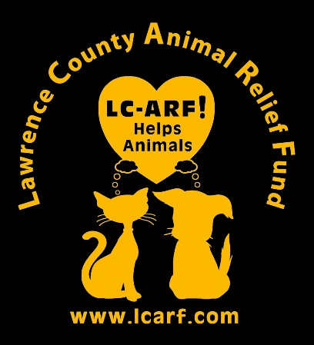

Vaccinations - If owners do not want a rabies vaccine to be administered to their pet, they must provide a current copy of the cat’s rabies vaccine certificate.
Cats considered for surgery – Kittens weighing at least 2 pounds, pregnant or in heat
Cats not considered for surgery – nasal discharge, seizures, heart murmur, poor body condition, severe skin disease, severe diarrhea or vomiting
Fasting instructions – Cats 5 months or older should not have any food or water after midnight the night prior to surgery. Kittens 4 months or younger should eat a small meal and drink water at 5:30 a.m. the morning of surgery.
Fees – Surgery Package $80.
(Spay/neuter, rabies FVRCP vaccination, flea and ear mite treatment if needed, pregnancy termination, in-heat spay, and eartip, if indicated. Clients should be prepared to pay for extra services if needed – prices below
FIV/FeLV Combo Test $25
FeLV Vaccine $15 (Requires negative FeLV Test)
Product pricing -Penicillin injection $5 Clavamox liquid $15
Animax ear ointment $10 Tobramycin Eye Drops $10 Capstar $5 Ivomec $5 Droncit $5 Strongid $5 Convenia injection $25

